Data PA, IIS, AOA and App Server Setup

1. **Data PA Setup**

Run “DataPASetup.exe” and take the defaults as presented. If the installation site does not have .Net Framework installed, the Data PA setup program will install a version. If this happens, run DataPASetup.exe again to complete the installation of the Data PA components.

Once the setup is complete, open “Services” and located the two services now running.

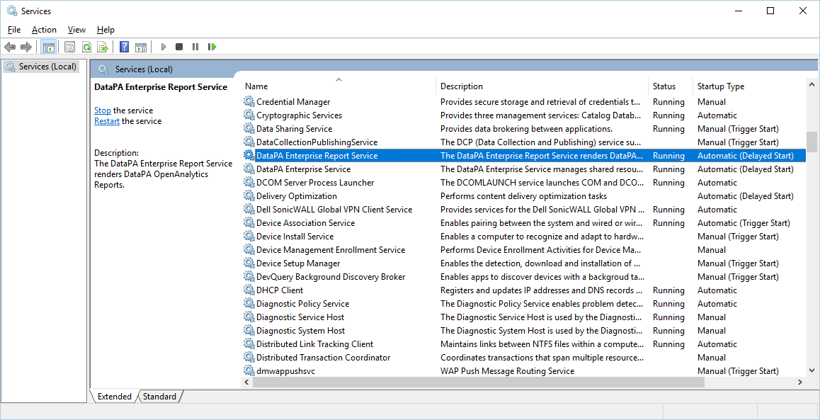

Right mouse click both of the Data PA Services to access the Properties. Set the “Startup Type” value to “Automatic (Delayed Start)”. The Data PA services can sometimes get ahead of other Assemblies it uses, so setting it to Delayed Start ensures those services are up and running before hand.

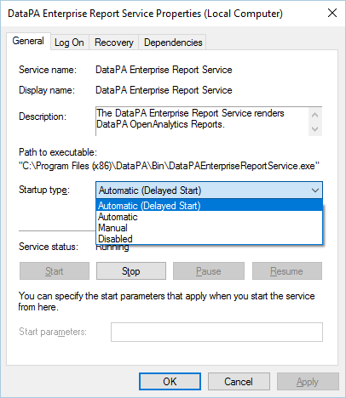

1. **Internet Information Services (IIS) Manager**
   1. From the Windows Control Panel, locate and access “Turn Windows features on or off”. Using the Windows Logo, simply type “Features” and Windows should present the “Turn Windows features on or off” application.

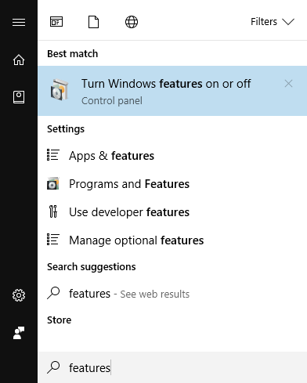

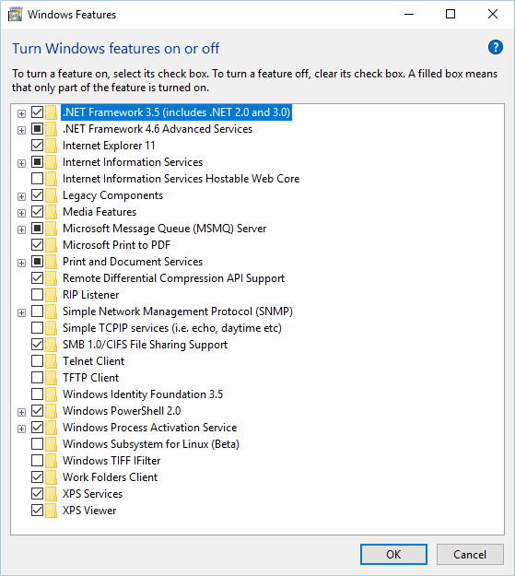

Mimic the image below to ensure the features checked are selected on the installation server.

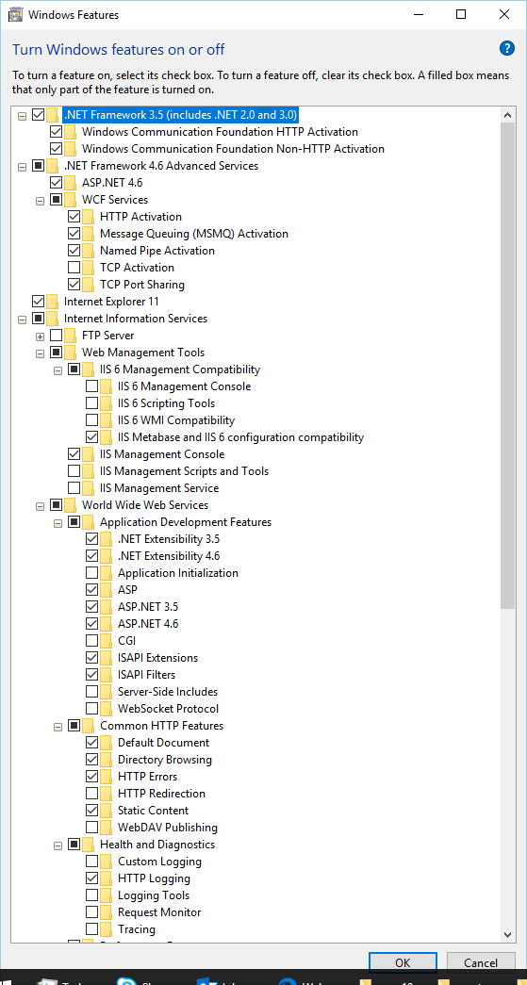

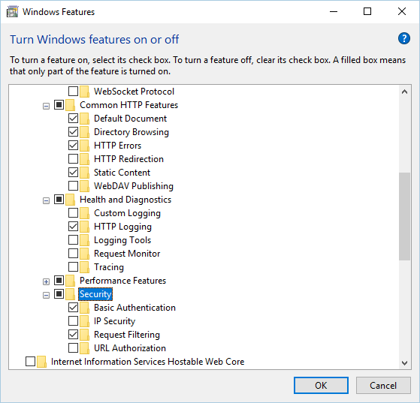

Select these values for “Security”.

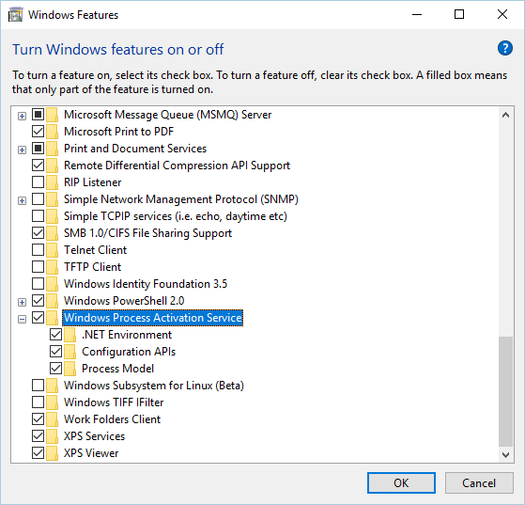

Select the above values for “Windows Process Activation Service”.

* 1. Using the Windows Logo, simply type “IIS” and Windows should present the “Turn Windows features on or off” application.

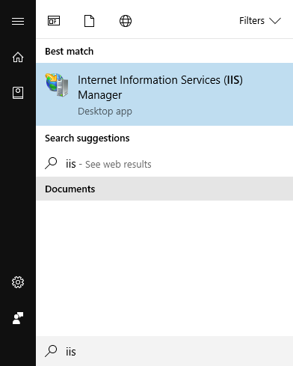

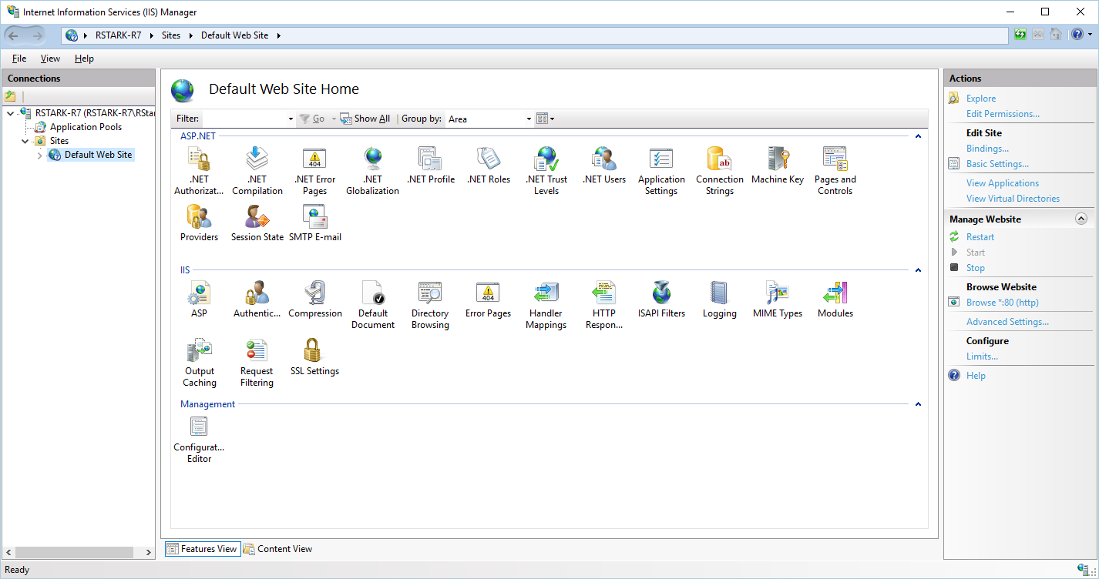

Under the “Default Web Site” should be an entry for “DataPA”. This indicates the Data PA Setup and Installation worked. Right mouse click on “Default Web Site” and select “Add Virtual Directory…”.

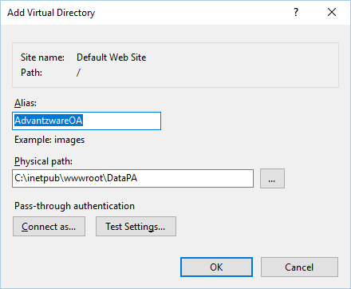

Enter “AdvantzwareOA” for “Alias:” and “C:\inetpub\wwwroot\DataPA” for “Physical Path:”. Click OK.

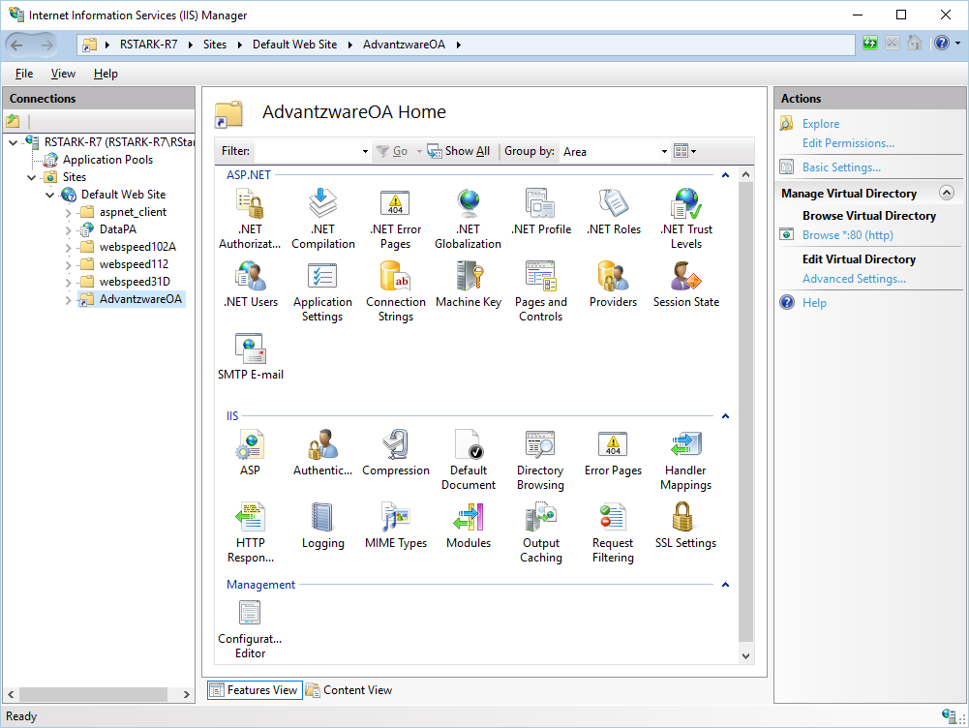

Now right mouse click “AdvantzwareOA”… and select “Convert to Application”.

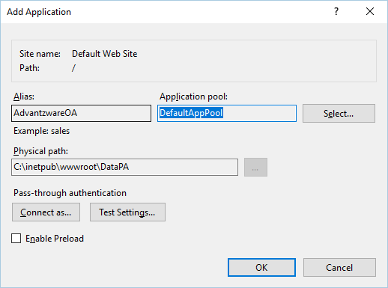

Click the “Select…” button to select an Application Pool.

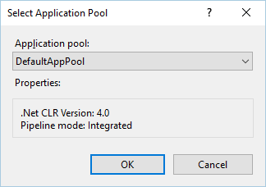

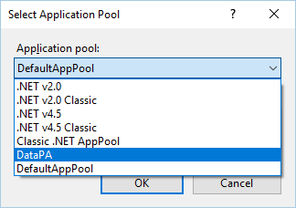

And Select “DataPA” and click OK.

Perform a “Test Connection” and it should show the following screen:

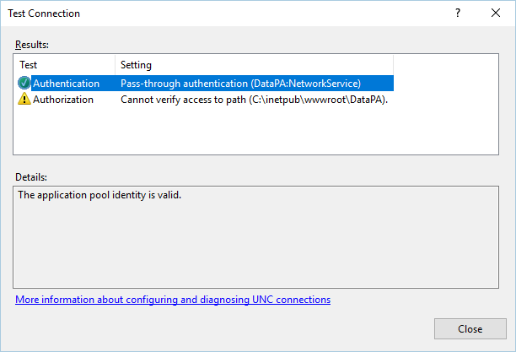

Ensure the “Default Web Site” is running. If not, Click the “Start” link on the right side of the screen.

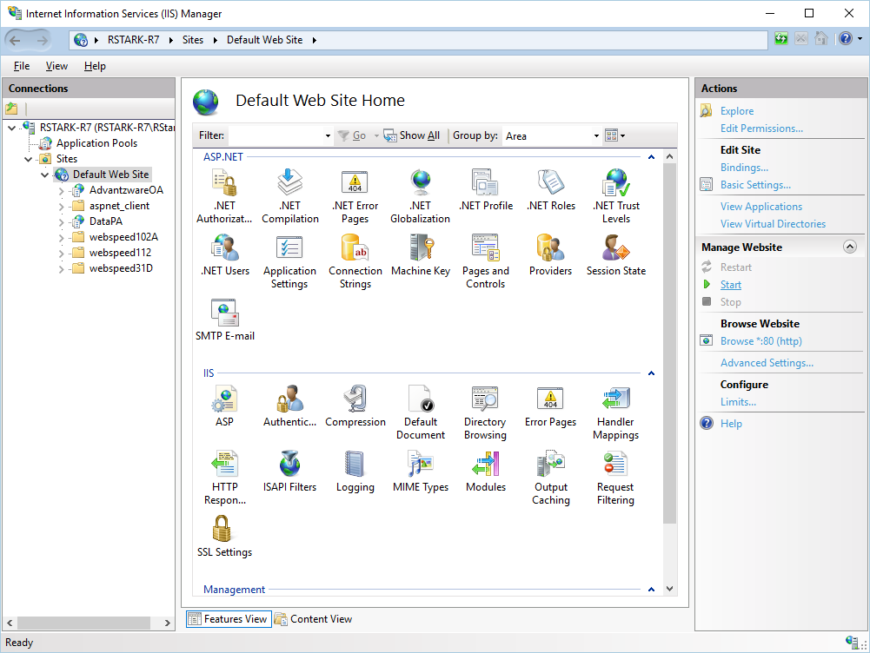

1. **AOA Setup**

Stop the DataPA Services.

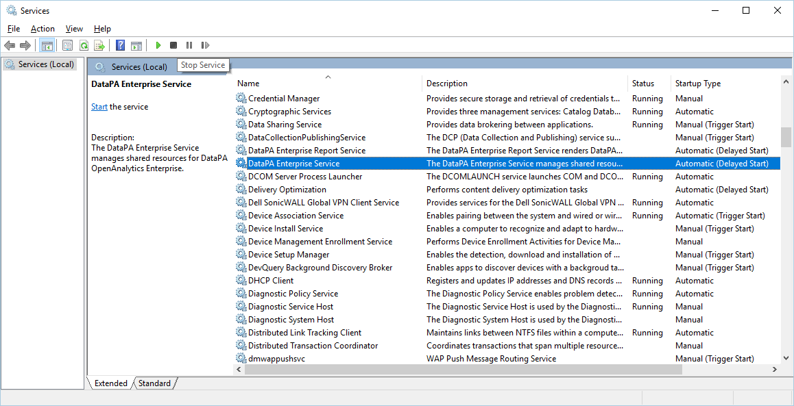

Navigate to “Resources\ProgramData\DataPA” directory and select its contents (if running Progress v10, select datapa101b.pl, if v11, select datapa111.pl). However, both being present does not cause any issues.

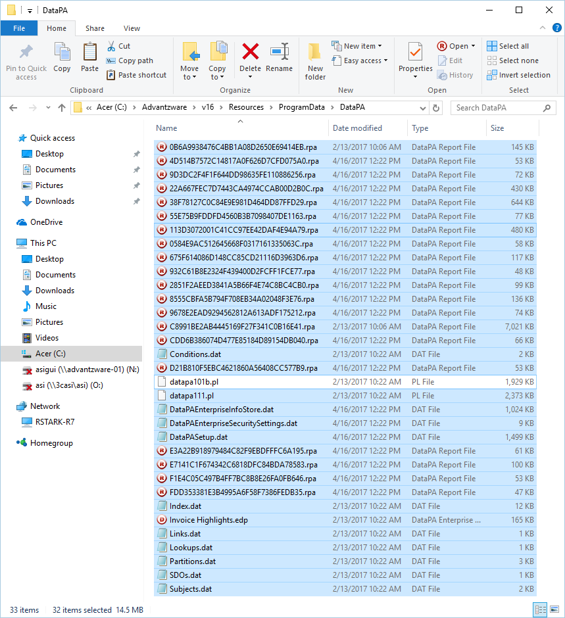

Now navigate to “C:\ProgramData\DataPA” (this is a hidden directory, so select in Windows Explorer to make it visible) and copy the files selected from “Resource\ProgramData\DataPA”.

Navigate to “Resources\inetpub\wwwroot\DataPA” and copies the two .html files to “C:\inetpub\wwwroot\DataPA”.

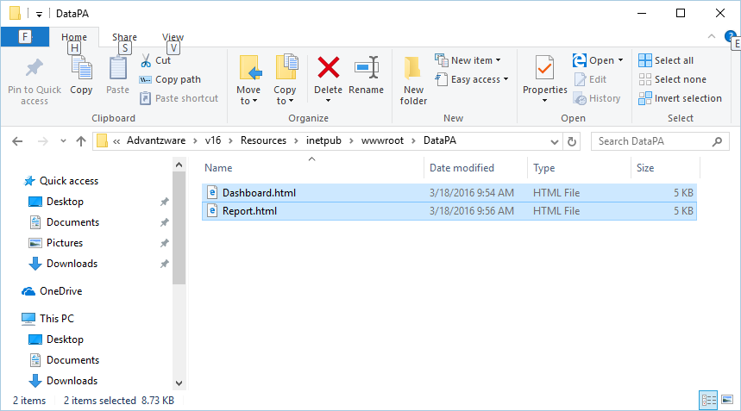

Short cut would be to copy “Resources\inetpub” directory and copy to “C:\”.

1. AOA App Server

Using Progress OE Explorer, a new App Server needs to be created, named asAOA. These settings are located in Progress install directory, usually “C:\Progress\Openedge” in file “ubroker.properties” with the following: (Note: Port Number 3091 is located in the default settings in element [UBroker.AS]

portNumber=3091

[UBroker.AS.asAOA]

appServerKeepaliveCapabilities=allowClientASK,allowServerASK

appserviceNameList=asAOA

autoStart=1

brkrDebuggerKeyAlias=default_server

brokerLogFile=@{WorkPath}\asAOA.broker.log

controllingNameServer=NS1

environment=asAOA

initialSrvrInstance=2

keyAlias=default_server

mqBrokerLogFile=@{WorkPath}\asAOA.mqbroker.log

mqServerLogFile=@{WorkPath}\asAOA.mqserver.log

operatingMode=Stateless

PROPATH=@{WinChar Startup\PROPATH};@{WorkPath};C:\ProgramData\DataPA;C:\ProgramData\DataPA\datapa111.pl;C:\PDrive\ASI\Repositories\Advantzware\Legacy;C:\PDrive\ASI\Repositories\Advantzware\Resources

registrationMode=Register-LocalHost

srvrLogFile=@{WorkPath}\asAOA.server.log

srvrStartupParam=-db advantzware -H localhost -S 2823 -ld asi

srvrStartupProc=AOA\appServer\aoaStart.p

uuid=37cb61f8f3397d86:-71d62ce:157c46c818e:-5737

All the value settings above are important, but critical values are highlighted and may require review of the installed environment to obtain the correct settings, such as the Service Port of the Advantzware Database and the PROPATH. The PROPATH should also include the start in directory, such as RCODE.

App Server asAOA:

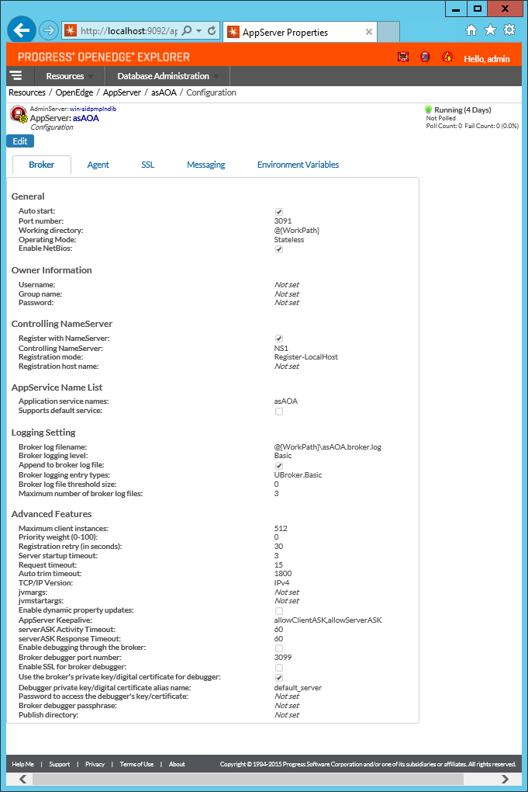

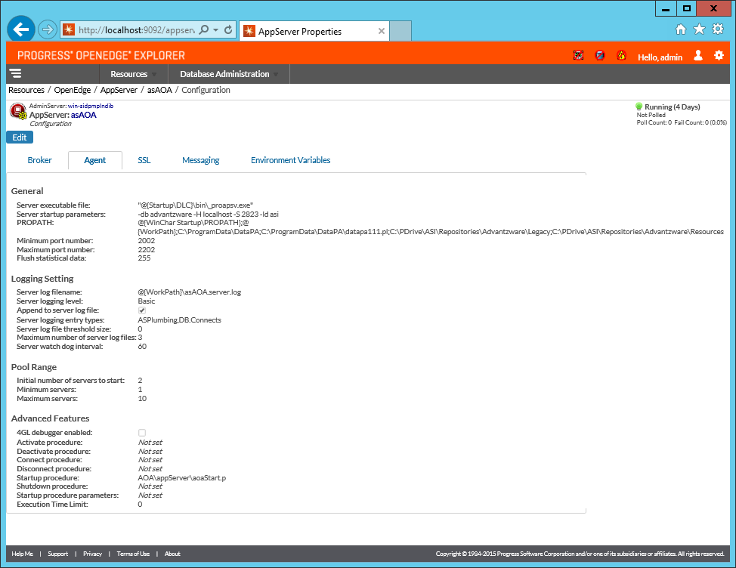

Name Server NS1:

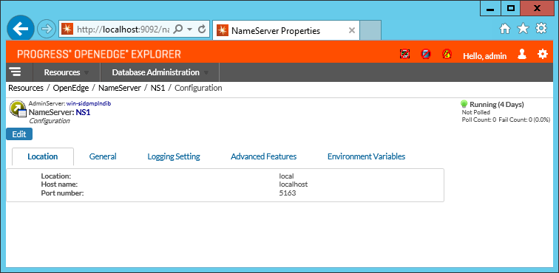

Name Server entries:

[NameServer]

allowRuntimeUpdates=0

autoStart=0

brokerKeepAliveTimeout=35

classMain=com.progress.nameserver.NameServer

collectStatsData=0

environment=

hostName=localhost

infoVersion=9010

ipver=IPv4

jvmArgs=

jvmStartArgs=

location=local

logAppend=1

logEntries=0

logEntryTypes=NSPlumbing

loggingLevel=2

logThreshold=0

multiCastGroup=

neighborNameServers=

numLogFiles=3

portNumber=5163

rmiWatchdogInterval=60

srvrLogFile=@{WorkPath}\ns.log

workDir=@{WorkPath}

#

# Sample definition of a NameServer

#

[NameServer.NS1]

autoStart=1

environment=NS1

srvrLogFile=@{WorkPath}\NS1.ns.log

The Name Server port number needs to be reflected in “NK1” “asAOA”.

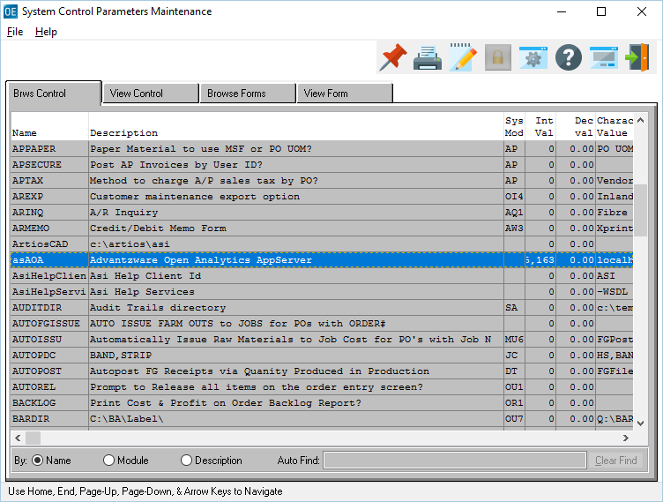

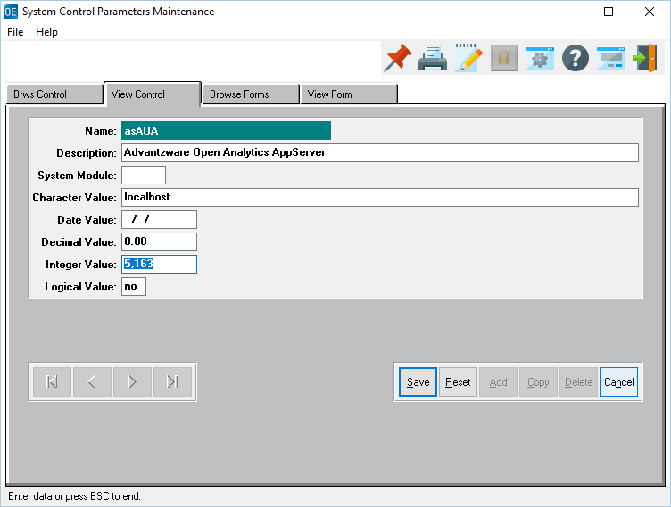

In order for clients to utilize the Data PA Scheduler, the Windows Registry needs to be checked for the “EnableAT” value. This setting allows users to schedule AT jobs to the Windows Task Scheduler.

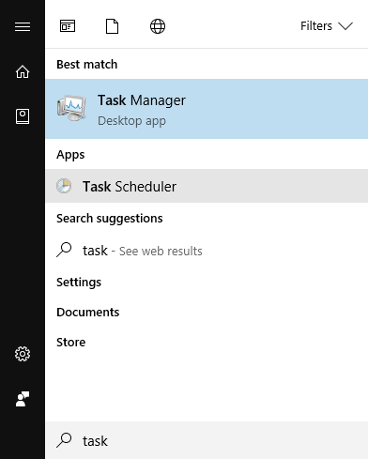

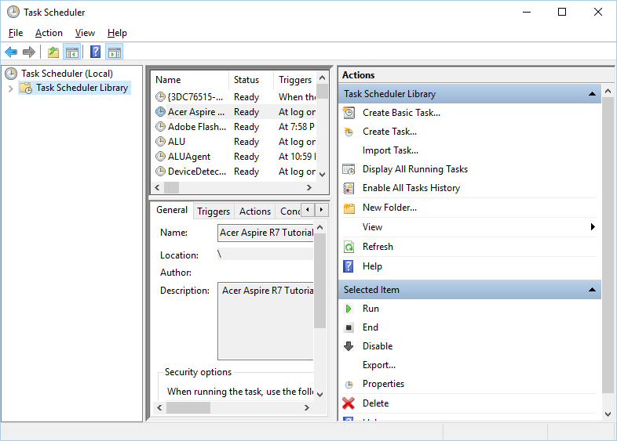

Run Registry Edit by searching for “RegEdit”.

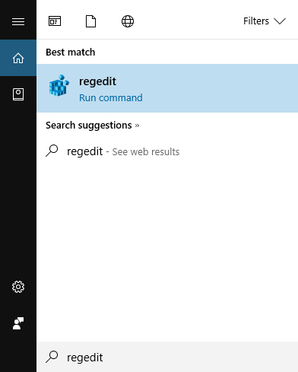

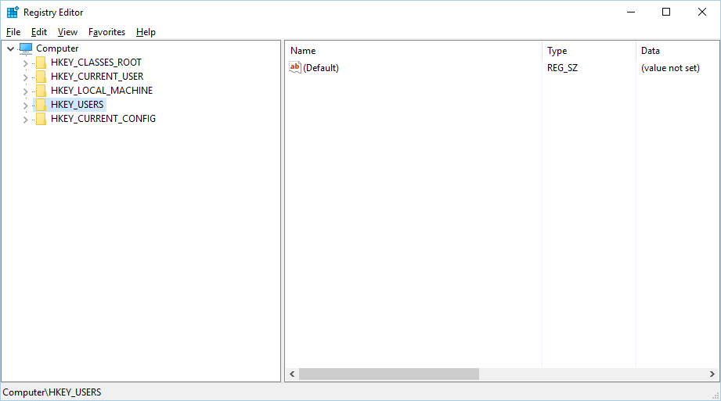

Navigate to the Registry Entry: “[HKEY_LOCAL_MACHINE\Software\Microsoft\WindowNT\CurrentVersion\Schedule\Configuration”.

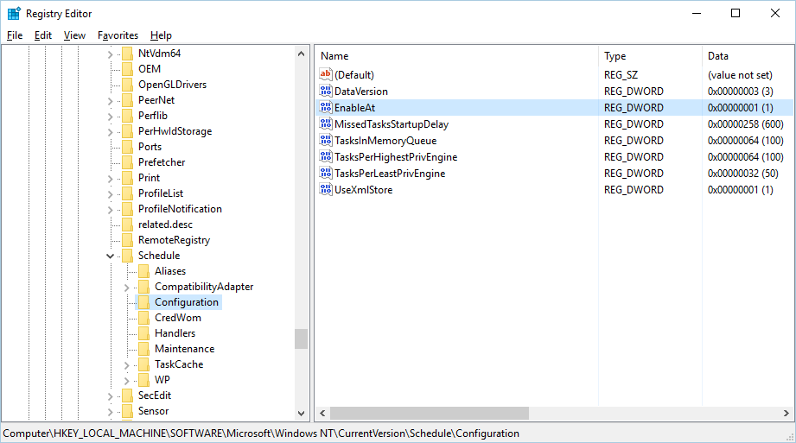

If “EnableAT” does not exist, it needs to be added by right mouse clicking “Configuration”, select “New”, DWORD (32 bit) Value.

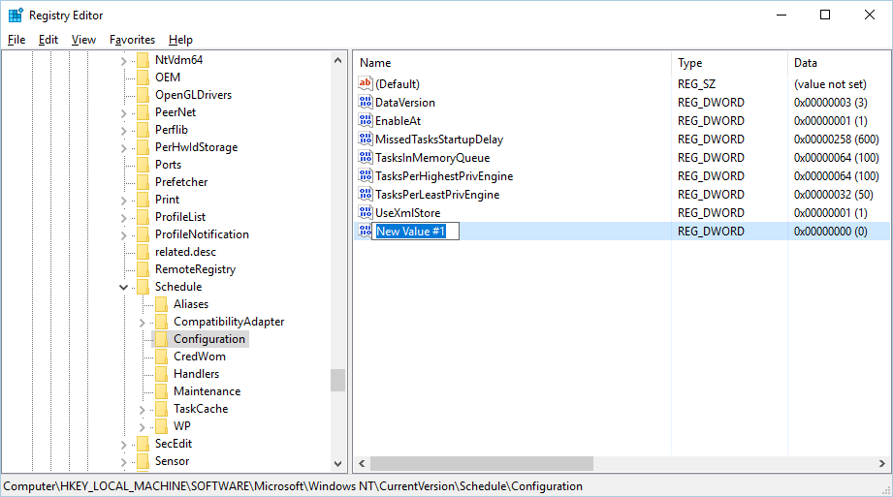

Set the “Name” to “EnableAT”. Double click “EnableAT” and set it’s value to “1”.

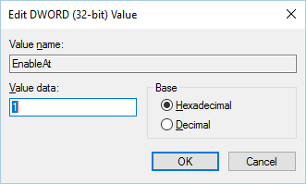

NOTE: Once this entry is complete, the server will require a REBOOT to take effect. Entries into Data PA Scheduler cannot be done until a REBOOT has been executed.